Meta Title:
MAB Building Contracting LLC | The Best Construction Company in Dubai & UAE
Meta Description:
Experience Dubai & UAE’s leading construction expertise.MAB Building Contracting LLC delivers quality, safety, and innovation expertise..

Keywords | UAE Volume | KD
construction company in UAE | 2.9k | NA
construction company UAE | 2.9k | NA
best construction company in UAE | 260 | NA
best construction company UAE
construction companies in uae | 2.9k | 27
best building construction company in uae
top construction companies in uae | 720 | 19
Construction services in UAE

Build Your Vision with the Best Construction Company in UAE
From blueprint to landmark, we turn concepts into UAE’s most iconic spaces. Backed by precision craftsmanship, relentless safety standards, and seamless project execution, we deliver futures built on trust.

Start Your Project Today
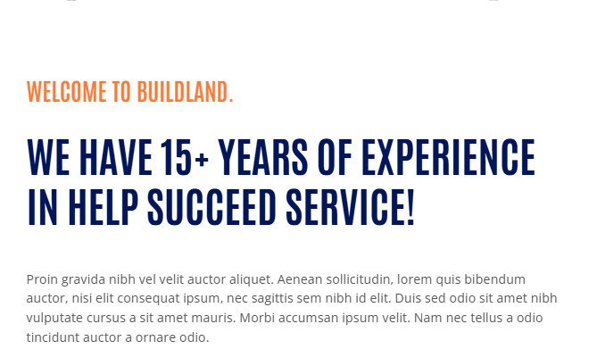
Welcome to MAB Building Contracting LLC:
Transform Your Visions into Reality with Leading UAE Construction Company
At MAB Building Contracting LLC, we help you transform your vision into a reality through innovation, the highest quality, and excellent service. We have over fifteen years of experience, which highlights our ability to turn ideas into tangible projects. From constructing tall buildings to renovating competitive architecture, MAB Building Contracting LLC is the best construction company in UAE for your construction needs.

Schedule a Site Consultation

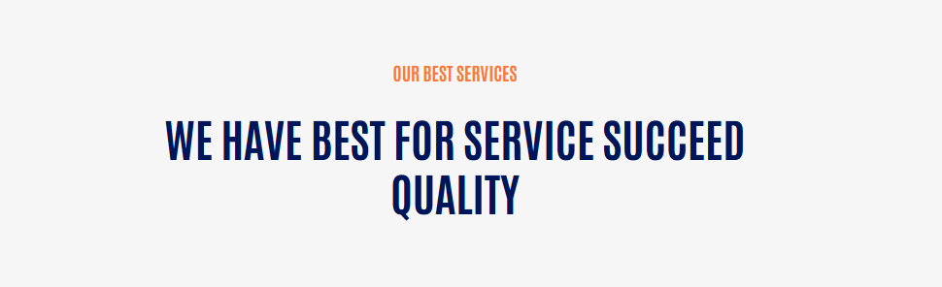

MAB Building Contracting LLC Construction Services:
Build Beyond Boundaries With Quality Construction Services in UAE

Design and Engineering | Construction Management | General Contracting
Our design and engineering services offer quality solutions that are unique and environmentally friendly, based on your project requirements. | We oversee your project time and cost estimations and management, alongside resource control that will help in acquiring and executing your project. | We address all aspects of construction, starting from the establishment of project feasibility to its completion. We also coordinate on the site acquisition.
Electrical & Power | Sanitary & Plumbing | Maintenance and Renovation
Efficiency with safety to run your project is what we offer. We have a dedicated electrical team that installs electrical systems of the highest standards. | Sufficient plumbing and sanitation are crucial. Our experts always ensure that all the water systems are installed properly to the required standards. | Our maintenance and renovation services are part of keeping your property in good condition and looking for solutions to any problem that may arise.

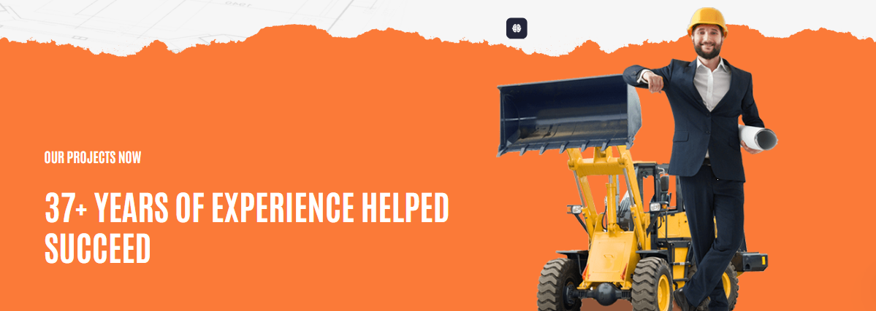

Our Successful Projects
Explore 37+ Years of UAE Construction Excellence


Accelerate Growth with UAE’s Top Construction Partner. Feel Free to Contact Us.
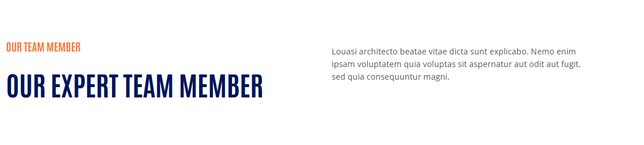
MAB Building Contracting LLC Team Member
Our Game Changer Team Members
At MAB Building Contracting LLC, the first and most valuable resource is our team, which consists of attentive, competent, and creative people. Our team is the reason why MAB Building Contracting LLC is among the best construction companies in uae.
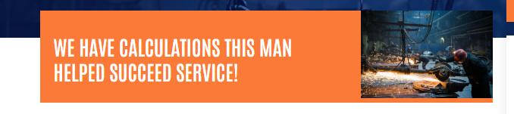

From Calculations to Collaborations, Success on Every Frontier


Get Your Free Quote
MAB Building Contracting LLC is not only constructing houses but also constructing success. Our highly qualified staff and unique approach guarantee that your idea will come to life. For more information, contact us today so that you can begin a successful construction journey.

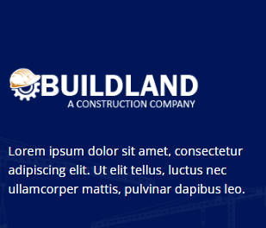

Leading UAE construction experts crafting innovative, safe, and precise projects since 2008. Partner with confidence.

